**Objectives**

In this hands-on lab, you will learn how to execute steps involving clean up and push back to remote Git.

**Step 0 -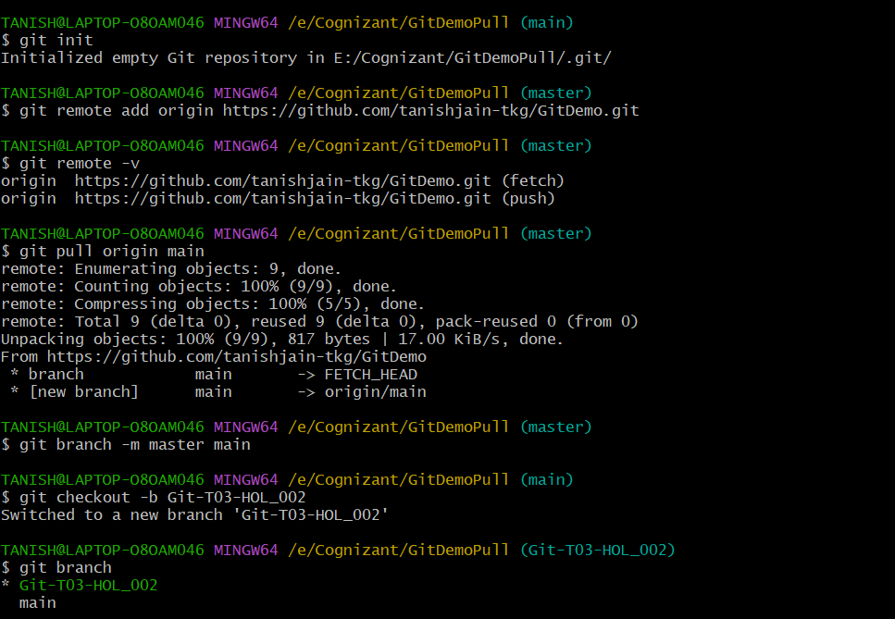 Setup**

**Step 1 -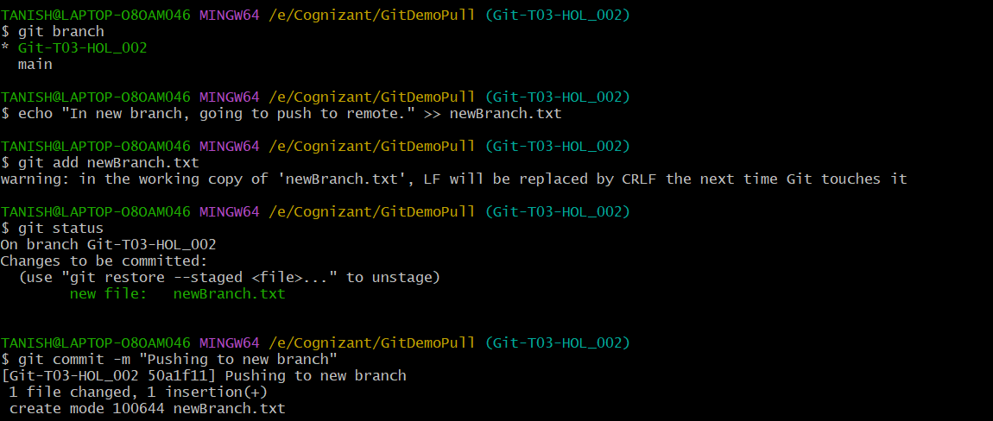 Making changes in new branch and pushing to remote repo**

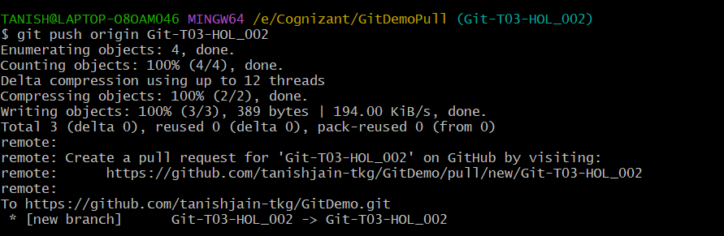

**Step 2 -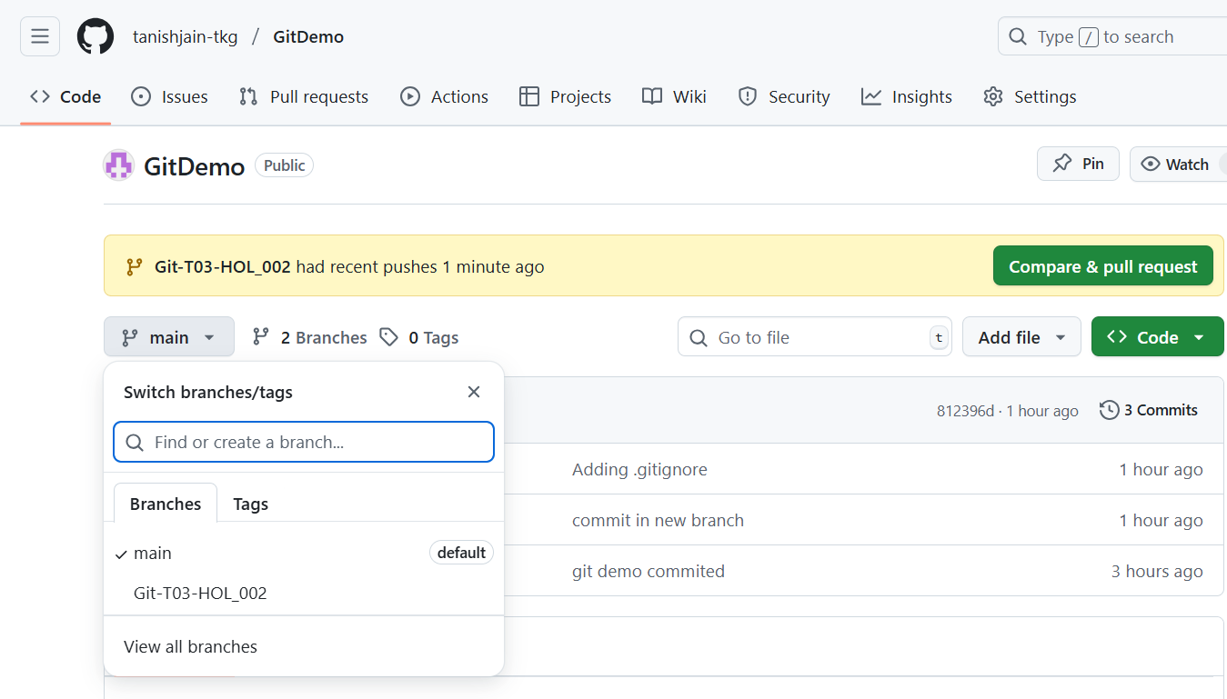 Observing changes in remote repo**